lab exercise

printbylevel

Background:

1. A different kind of binary tree traversal scheme is to visit the nodes level by level. Your task in this lab exercise is to print out a binary tree by level from left to right. For example, this binary tree of letters (diagram below) will result in the following output of letters:

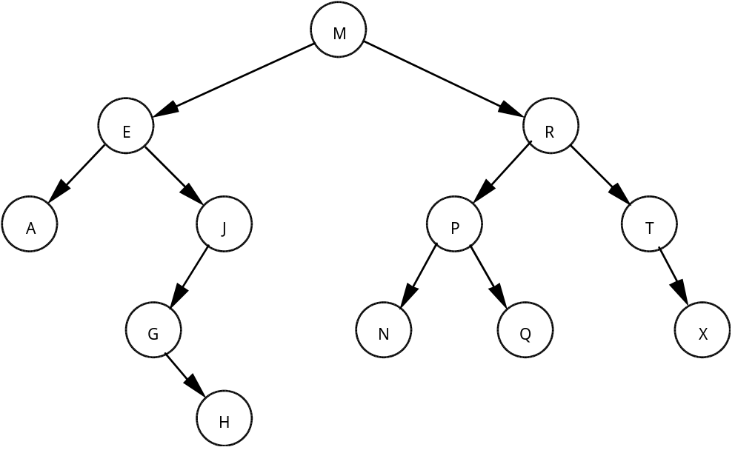

M E R A J P T G N Q X H

Assignment:

1. Use the apqueue class to provide the necessary queue routines for this lab exercise.

2. Starting with the earlier binary tree lab exercise in Lesson 39, L.A.39.1, TreeStats, build a binary tree of characters ordered by letter.

3. Write a function printLevel that prints out the tree, level by level from left to right. The output can be formatted in one line as in the above example. Any use of a queue is restricted to the operations allowed in the apqueue abstract data type.

Instructions:

1. Use the same data files (FileA.txt) and (FileB.txt) as in the earlier binary tree lab in Lesson 39, L.A.39.1, TreeStats.

2. Turn in your source code and the two run outputs.

